

Request for Information
Prospective Not-For-Profit Charter School Education Corporation Trustees

Guidance and Form

For Charter Schools Authorized by the
State University of New York Board of Trustees

Updated: November 2018

SUNY Charter Schools Institute
SUNY Plaza
353 Broadway
Albany, NY 12246
(518) 445-4250 (phone)
www.newyorkcharters.org

INTRODUCTION

Serving on a public charter school education corporation board is a position of great trust and responsibility. The law charges trustees with overseeing the education of all students enrolled in each school the not-for-profit education corporation has the authority to operate, the expenditure of public and private monies directed to the school(s), and, if applicable, the oversight of any charter/education management organization (“CMO/EMO”).

The State University of New York Board of Trustees (the “SUNY Trustees”) requires all new education corporation board members be approved by the SUNY Charter Schools Institute (the “Institute”) pursuant to the terms of the education corporation’s Charter Agreement. The Institute uses this Request for Information (“RFI”) form as part of that process. Once the board elects a proposed trustee, the Institute requests the prospective trustee to complete the following form by providing answers to each of the items, and signing the certification.

Only in very rare cases does the Institute reject properly approved prospective trustees who have provided all information requested on this form. These cases are generally limited to prospective members who would have severe conflicts of interest in fulfilling their fiduciary or other duties as an education corporation trustee, who are proposed to be seated in violation of the education corporation’s charter or by-laws, or whose criminal history would disqualify them. Questions related to conflict of interest may be addressed to the education corporation’s counsel or counsel at the Institute.

Pursuant to New York’s Freedom of Information Law (“FOIL”), any personal information listed on or attached to this form (including the Charter School Trustee Contact Information form) that would constitute an unwarranted invasion of personal privacy will not be disclosed (home address, email, telephone number, etc.).

- Request for Information

- Applicable Charter Agreement Provisions

The following image shows the applicable provision from the Model Charter Agreement (available at http://www.newyorkcharters.org/wp-content/uploads/Model-Charter-July-2017.pdf), which is the same or very similar to that of each education corporation’s Charter Agreement:

- Section 2.3, Selection of New Education Corporation Board Members.

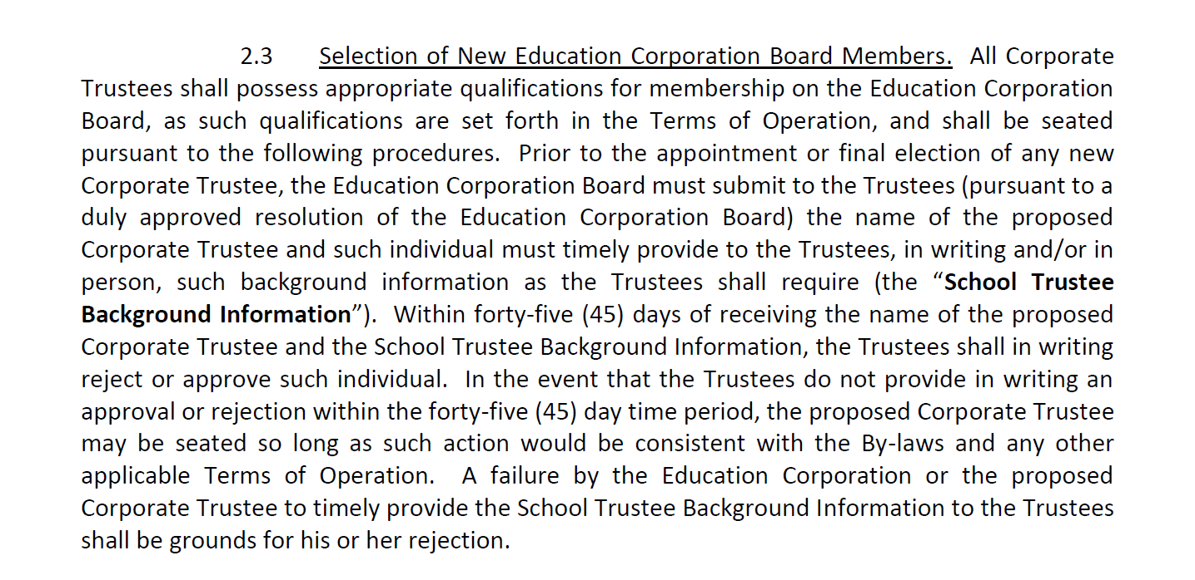

- Applicable Laws and Regulations

None.

- Discussion

In order to legally seat a person on a charter school board, the following procedures should generally be followed as well as any specific provisions contained in education corporation’s by-laws:

- When a board seat becomes vacant or is created, the board (by committee or otherwise) should seek nominations for a person to fill the vacant seat with appropriate qualifications per the Charter Agreement and by-laws requirements.

- The board secretary or other administrator should review the by-laws to determine the proper number of trustees that may be seated on the board, and that the number is within the proper range (e.g., 7-11). If the board has more members than the upper end of the range, a request to amend the by-laws must be made to the Institute or the education corporation may not fill the seat. In cases where the board is expanding the number of trustees (as opposed to filling a vacancy) the board must do so prior to the election of the proposed trustee (even if being voted at the same meeting) and clearly reflect same in the minutes.

- Note: the legal limits on board size are 5 minimum and 25 maximum, although best practice has shown boards of 11 or under to be effective.

- The board secretary or other administrator should review the following to determine the proper qualification of the prospective board member:

  - Charter Agreement section entitled “Governance; Education Corporation Board; By-laws” (Section 2.2 in recent charters) for the following:

    - compliance with the 40% rule (no more than 40% of the school board may be affiliated with any single entity unless the school has received a waiver from the SUNY Trustees); and,

    - compliance with provisions prohibiting or restricting board membership for persons associated with a CMO/EMO.
  - Charter Agreement Exhibit A, “Additional Assurances and Terms,” if any, which may contain restrictions on board membership or a waiver thereof;
  - Charter Agreement Exhibit A, “Terms of Operation;” any sections dealing with governance;

  - By-laws, which may:

    - state what type or “class” of trustee must be elected, e.g., parent, teacher representative, community member;
    - state any conditions that must be met prior to the election or nomination of a proposed trustee (vote of the parent/teacher organization; vote of partner organization, etc.);
    - direct how the trustee will be elected or appointed (super-majority vote, vote of corporate member, etc.); and/or,
    - state how long the term of a trustee will be. When vacant seats are filled, the new trustee serves for the remainder of the prior trustee’s term. When new seats are created, the board, or other methodology in the by-laws, may dictate the length of the term, which may be staggered with other terms. It is good practice for the secretary to keep a multi-year elections calendar to track each trustee’s term.

The education corporation board or corporate member elects or appoints the prospective trustee at a duly convened meeting of the applicable board with a quorum and following any by-laws restrictions on elections. The Institute will approve or reject such proposed trustee in writing within 45 days of submission of all of the required documentation:
- complete Request for Information, Prospective Charter School Education Corporation Trustee (“RFI form”);
- resume or brief biographical information;
- updated list of board of trustees; and,
- evidence of proper election (e.g., signed resolution or meeting minutes reflecting vote).

If the Institute takes no action within the 45 day period, the person may be seated as a school trustee.

- Responsible Tasks

- Submit a copy of the signed resolution electing the prospective trustee or the meeting minutes showing such election.
- Submit the original RFI form. After each prospective trustee reviews the by-laws, code of ethics and any conflict of interest policies of the education corporation, the board secretary or administrator should have each prospective trustee complete a RFI form, which the education corporation or proposed trustee must submit to the Institute together with a resume or brief biographical information.
- Submit an updated board list to the Institute reflecting the proposed trustee’s election.
- After approval by the Institute, the board secretary or other administrator should inform the new trustee, and all trustees, of his or her official seating on the board. The trustee may now be counted for purposes of quorum and vote.
- As a reminder, the education corporation must notify the SUNY Trustees within five (5) business days of any of the following education corporation trustee actions: removal; resignation; expiration of term without re-election; or, otherwise leaving the board.

Request for Information

Prospective Charter School Education Corporation Trustee

Form

Please provide the following information.

Background

- Name of charter school education corporation for which you intend to serve as a trustee.

- Full name:
Home Address:
Business Name and Address:
Home telephone No.:
Work telephone No:.
E-mail address:

- A brief educational and employment history (or you may attach a resume):
Resume attached.

- Please affirm that you will be at least 18 years old by the date of appointment to the education corporation’s board. I affirm.

- Please indicate whether you currently or have previously served on a board of a school district, another charter school education corporation, a non-public school or any not-for-profit corporation. Does not apply to me. Yes, .

- Please indicate if you have ever been convicted of a misdemeanor related to honesty or trustworthiness, or a felony. If the answer to this question is yes, please provide details of the offense, the date, disposition, etc. Does not apply to me. Yes, .

- Please indicate if you have ever entered into a settlement agreement, consent decree, adjournment in contemplation of dismissal, assurance of discontinuance or other, similar agreement with the Securities Exchange Commission, Internal Revenue Service, the U.S. attorney general or the attorney general of any state, a U.S. or district attorney or any other law enforcement or regulatory body concerning the discharge of your duties as a board member of a for-profit or not-for profit entity or as an executive of such entity. If the answer to this question is yes, please provide details of the agreement.
Does not apply to me. Yes, .

Conflicts

8. Please indicate whether you or your spouse knows any of the other charter school education corporation trustees, or prospective or former trustees. If so, please indicate the precise nature of your relationship. I / we do not know any such trustees. Yes, .
9. Please indicate whether you or your spouse knows any person who is, or has been in the last two years, an employee of the education corporation. If so, indicate the precise nature of your relationship.
I / we do not know any such employees. Yes, .
10. Please indicate whether you or your spouse knows anyone who is doing, or plans to do, business with the education corporation or any of the schools it has the authority to operate (whether as an individual or as a director, officer, employee or agent of an entity). If so, indicate and describe the precise nature of your relationship and the nature of the business that such person or entity is transacting or will be transacting with the education corporation. I / we do not know any such persons. Yes, .
11. Please indicate if you, your spouse or other immediate family members anticipate conducting, or are conducting, any business with the education corporation or any school it has the authority to operate. If so, please indicate the precise nature of the business that is being or will be conducted. I / we do not anticipate conducting any such business. Yes, .
12. If the education corporation or any of the schools it has the authority to operate contracts with an educational service provider (a management company, whether for-profit or not-for-profit), please indicate whether you or your spouse know any employees, officers, owners, directors or agents of that provider. If the answer is in the affirmative, please describe any such relationship.
Not applicable because the education corporation does not contact with a management company or charter management organization.
I / we do not know any such persons.
Yes, .
13. If the education corporation contracts with an educational service provider including a charter management organization, please indicate whether you, your spouse or other immediate family members have a direct or indirect ownership, employment, financial, contractual or management interest in the provider. For any interest indicated, please provide a detailed description. N/A. I / we have no such interest. Yes, .
14. If the education corporation or any of the schools it has the authority to operate is partnered with an educational service provider including a charter management organization, please indicate if you, your spouse or other immediate family member anticipate conducting, or are conducting, any business with the provider. If so, please indicate the precise nature of the business that is being or will be conducted. N/A. I / we or my family do not anticipate conducting any such business. Yes, .

- Please indicate whether you, your spouse or other immediate family members are a director, officer, employee, partner or member of, or are otherwise associated with, any organization which filed an application in conjunction with the education corporation, i.e., is partnered with the education corporation. (For the identity of all such organizations, please consult with the chair of the board.) To the extent you have provided this information in response to prior items, you may so indicate. Does not apply to me, my spouse or family. Yes, .
- Please indicate any potential ethical or legal conflicts of interests that would, or are likely to, exist should you be approved for service on the education corporation board. Please note that being a parent of a school student, serving on another charter school’s board or being employed by the school are conflicts that should be disclosed, but do not make you automatically ineligible to serve as a trustee. None. Yes, .

- Please indicate any individual, business, corporation, union association, firm, partnership, committee, proprietorship, franchise holding company, joint stock company, trust, non-profit organization, or other organization or group of people doing business with the education corporation, and in which such entity you and/or your immediate family members have a financial interest or other relationship. None. Yes, .

- Please indicate how you would handle a situation in which you believe one or more members of the education corporation’s board are involved in self-dealing (working for their own benefit, or the benefit of their friends and family). Please note that simply confronting the involved trustee is not usually a sufficient answer.

Other

- Please affirm that you have read the education corporation’s by-laws and conflict-of-interest policies (Code of Ethics). I affirm.
- Please provide any other information that you feel pertinent to the SUNY Charter Schools Institute’s review.

Certification

I, _________________________, certify to the best of my knowledge and ability that the information I am providing to the State University of New York/Charter Schools Institute in regards to my application to serve as a member of the board of trustees of the __{insert name of education corporation}___ is true and correct in every respect.

____________________________ ___________________________
Signature Date

