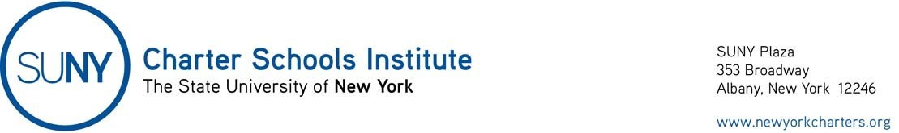

July 8 2020

Open Meetings Law

Governor’s Executive Order 202.48 (https://www.governor.ny.gov/news/no-20248-continuing-temporary-suspension-and-modification-laws-relating-disaster-emergency ), dated July 6, 2020, extends until August 5, 2020, the flexibility to charter school boards of trustees with respect to the Open Meetings Law (so long as certain conditions are met) provided in Governor’s Executive Order 202.1, dated March 13, 2020. See the Institute’s original guidance.

