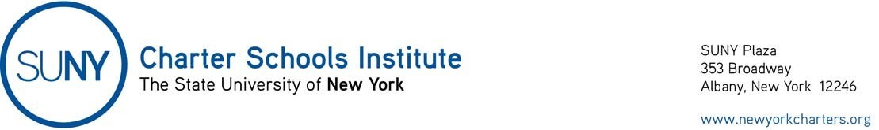

September 4, 2020

Open Meetings Law

Governor’s Executive Order 202.460 (https://www.governor.ny.gov/news/no-20260-continuing-temporary-suspension-and-modification-laws-relating-disaster-emergency), dated September 4, 2020, extends until October 4, 2020, the flexibility to charter school boards of trustees with respect to the Open Meetings Law (so long as certain conditions are met) provided in Governor’s Executive Order 202.48, dated July 8, 2020. See the Institute’s original guidance.

