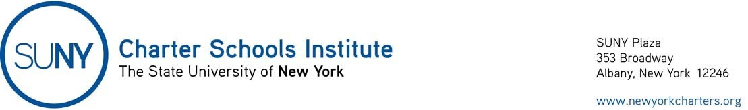
March 16, 2020
Charter School Lottery Flexibility Guidance
The SUNY Charter Schools Institute provides this guidance to help schools understand the legal requirements of, and current flexibility with respect to, admissions lotteries.
April 1st Date
As background, the New York Charter Schools Act does not require charter schools to hold lotteries on April 1st of each year. Rather, schools must admit all students who have applied by April 1st if there are not enough applications to fill a grade level (per N.Y. Education Law § 2854(2)(b)). For example, a school with 75 seats open in Kindergarten that receives 60 Kindergarten applications would admit all those students without a lottery after April 1st. Thereafter, the school could continue to enroll students in each grade until the 75 slots are filled, and then establish a waitlist in accordance with its admission policy. If a school receives more applications than seats available in a grade by April 1st, then the school must hold a lottery.
Lottery Dates
As long as a charter school places in the lottery all of the applications it receives by April 1st, the school may hold the lottery after April 1st. Most schools have lottery dates determined by admissions policies. Under the current situation, the Institute will allow schools to vary those dates in accordance with this guidance without further approval.
Conducting the Lottery
Education Law § 2854(2)(b) and 8 NYCRR § 119.5 set parameters for conducting lotteries including provisions to make lotteries open to the public in accordance with the Public Officers Law. The Governor’s Executive Order 202.1, dated March 13, 2020, relaxed parts of the Public Officers Law giving schools flexibility in conducting lotteries as follows:
- Schools will not have to offer in person, public access to the lottery so long as:
  - electronic access is provided in real time;
  - the school makes a recording (audio or video with audio) of the lottery and,
  - the school later makes a transcription (or closed captioning) available.
- Schools must still notice the lottery in accordance with the Public Officer Law by:
  - providing notice to the news media, and posting a notice in the usual public location 72 hours before the lottery; and,
  - posting a notice on the school’s website.
School communications should tell parents they do not need to be present at the lottery to obtain a seat, and that the school will inform them if their child has been selected in the lottery. If a school wants to offer a public viewing location for those without web access, it should encourage parents at the site to distance themselves and follow Center for Disease Control or other health guidelines. The school may also want to spread the timing of lotteries by grade.
The Institute will work with schools in providing the flexibility above, which will not require a charter revision.
While the Public Officers Law flexibility will currently expire on April 11, 2020, we understand schools may want to wait until after April 20, 2020 to conduct lotteries. Please contact the Institute if that is the case, and we will work with your school on accommodations. Of course, if the Executive Order is extended or revised, we will notify you.

