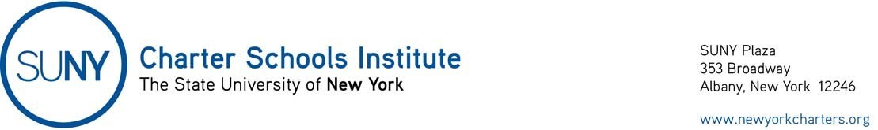Guidance on Per Pupil Billing
The Institute understands school shutdowns as a result of the Corona virus have generated questions about how charter schools should bill districts under NY Education Law §2856. As of today, the existing deadlines in law and regulations have not changed, but the Governor’s Executive Order 202.4 (EO 202.4) closing all schools is in effect. We offer the following as the best available information knowing that it will not answer all questions:
- Per Pupil Billing Invoice #6:
  - For New York City Schools, -the online application to submit invoices for Payment 6 opened on 9:00AM on Wednesday, March 18, and will close COB Friday, March 27.
  - Please complete the payment cycle 6 invoice following existing guidance.
  - For schools outside of NYC, the normal billing deadlines should be followed.
  - We are waiting for guidance from NYSED and others on how COVID-19 closures will impact per pupil payments However, the consensus among authorizers is that schools should bill normally (as if students were present) for the period of EO 202.4 (March 16 through the end of the billing period). If your school voluntarily closed earlier, please note that in the FTEs.
  - We expect that districts will pay the bills as normal and any needed adjustments will be captured in the reconciliation invoice due in July.
- Students with Disabilities Services: NYCDOE is collecting questions from the field for FAQ/Q&A they are currently drafting and hoping to release soon. Again, during the EO 202.4 period (March 18 to end of billing period), the school should bill as if it was providing services normally.
- ATS: NYCDOE will be sending out information for how schools can access ATS remotely.
- Fiscal Questions: NYCDOE is compiling a list of questions from the field as to per pupil billing/funding. NYCDOE will be working with NYSED to answer.
- Upstate Charters: Please communicate with each sending district to ensure the district’s understanding of the continuation of existing procedures.
Please notify the Institute of any issues that arise during billing submissions and communications with sending districts either through charters@suny.edu or directly to Barbara Acenowr at Barbara.acenowr@suny.edu.
We will provide updates to this guidance as information becomes available.

