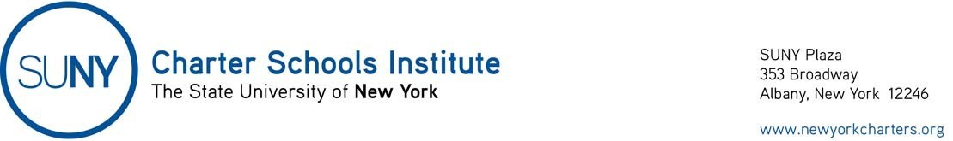
April 10, 2020

Open Meeting Laws

Governor’s Executive Order 202.14 (https://www.governor.ny.gov/sites/governor.ny.gov/files/atoms/files/EO_202.14_final.pdf), dated April 7, 2020, extends until May 7, 2020, the flexibility to charter school boards of trustees with respect to the Open Meetings Law (so long as certain conditions are met) provided in Governor’s Executive Order 202.1, dated March 13, 2020. See the Institute’s original guidance.

