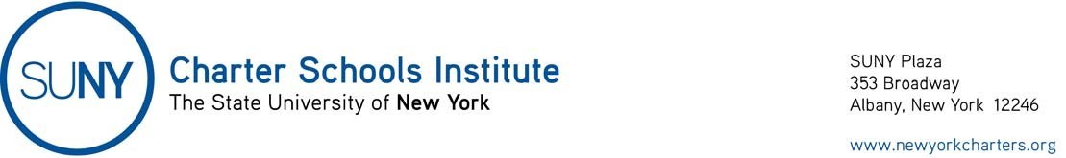
March 13, 2020
Open Meeting Laws
Governor’s Executive Order 202.1, dated March 13, 2020, provides flexibility to charter school boards of trustees with respect to the Open Meetings Law so long as certain conditions are met as follows:
- Board members can participate by telephone conference call, not just by videoconference, and count for purposes of quorum and voting;
- While the meeting must be publicly noticed, and noticed to the media, the meeting notice does not need to include each site from which a board member may participate; rather, it must include notice of how the public can view or listen to the meeting live; and,
- Board meetings conducted under the flexibility of the Executive Order 202.1 must be recorded by the board, and later must be transcribed with the transcription available to the public through the Freedom of Information Law.
This flexibility will expire on April 11, 2020. If the Executive Order is extended or revised, we will notify you.
The relevant language of the Executive Order 202.1 suspends:
“Article 7 of the Public Officers Law, to the extent necessary to permit any public body to meet and take such actions authorized by the law without permitting in public in-person access to meetings and authorizing such meetings to be held remotely by conference call or similar service, provided that the public has the ability to view or listen to such proceeding and that such meetings are recorded and later transcribed.”

