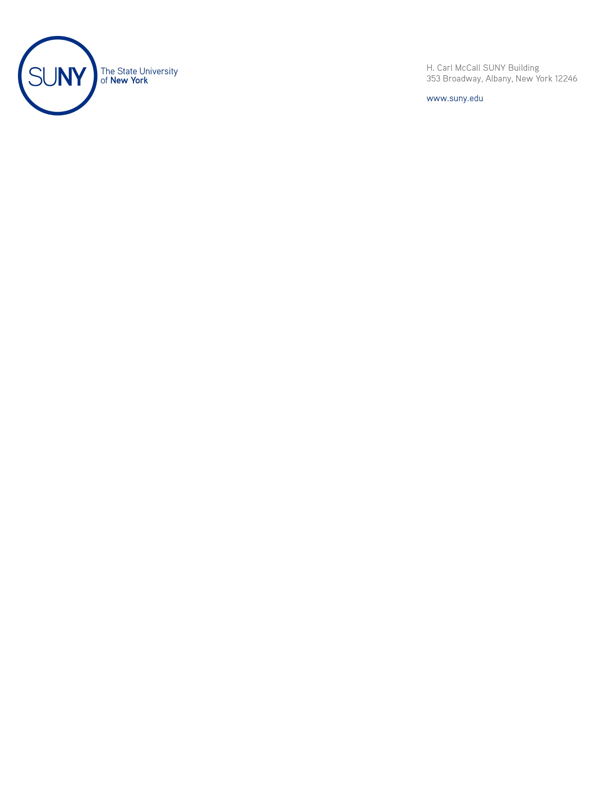

M E M O R A N D U M

March 17, 2021

To: Members of the Charter Schools Committee

From: Joseph W. Belluck, Chair, Charter Schools Committee

Subject: Approval of the Application for Charter Renewal of Broome Street Academy Charter High School (Manhattan)

Action Requested

The proposed resolution authorizes the approval of a five-year, full-term charter renewal for Broome Street Academy Charter High School pursuant to New York Education Law § 2851(4).

Resolution

I recommend that the Charter Schools Committee adopt the following resolution:

Whereas the Charter Schools Committee, acting on behalf of the Board of Trustees, as required by Subdivision 2851(4)(e), has considered, prior to approval of the application for charter renewal of Broome Street Academy Charter High School (the “Education Corporation”), located in Manhattan, the means by which the Education Corporation will meet or exceed the enrollment and retention targets of students with disabilities, English language learners, and students who are eligible applicants for the federal Free and Reduced Price Lunch program as set forth in the application, which targets were prescribed by the State University of New York Charter Schools Institute (the “Institute”) on behalf of the Board of Trustees; now, therefore, be it

Resolved that the Education Corporation’s application for charter renewal, be, and hereby is, approved and its charter be, and hereby is, renewed through and including July 31, 2026; and, be it further

Resolved that: 1) the Education Corporation’s school as described in its application for charter renewal meets the requirements of the New York Charter Schools Act of 1998 (as amended) and applicable laws, rules, and regulations; 2) the Education Corporation can demonstrate the ability to operate the school in an educationally and fiscally sound manner; and, 3) approving the renewal application and renewing the charter is likely to improve student learning and achievement and materially further the purposes set out in Education Law § 2850(2); and, be it further
Resolved that the Institute, acting for the Board of Trustees, be, and hereby is, directed to: 1) enter into a proposed renewal charter with the Education Corporation in accordance with this resolution, which proposed charter shall include such assurances and terms as the Institute shall deem necessary and appropriate; and, 2) thereafter, submit the proposed charter to the New York State Board of Regents for its review, comment, and potential approval.

Background

The New York Charter Schools Act of 1998 (as amended) permits the Board of Trustees to renew the charters of education corporations it has authorized, and to renew such corporations’ authority to operate charter schools. Pursuant to Resolution No. 2012-038, dated June 12, 2012, the Board of Trustees delegated authority to renew charters to the Charter Schools Committee.

Pursuant to the Policies for the Renewal of Not-for-Profit Charter School Education Corporations and Charter Schools Authorized by the Board of Trustees of the State University of New York (the “SUNY Renewal Policies”) (last amended September 4, 2013 and available at: https://www.newyorkcharters.org/
wp-content/uploads/SUNY-Renewal-Policies.pdf), the SUNY Charter Schools Institute (the “Institute”) generally conducts a renewal site visit; reviews the information in the renewal application as well as other relevant information such as assessment data and site visit reports; interviews education corporation trustees and staff; and produces a draft renewal report containing its findings and preliminary recommendation. The draft renewal report also contains an evaluation of the performance of an education corporation’s school over the charter term based on the criteria provided in the renewal benchmarks described in the SUNY Renewal Policies. The education corporation receives a copy of the draft renewal report and is given an opportunity to comment on it before it is finalized. The Institute makes final renewal reports available in its Albany office and at: http://www.suny.edu/about/leadership/board-of-trustees/meetings/
meetingNotices.cfm. Copies of applications for charter renewal are on file in the Albany office of the Institute.
As set forth in the Institute’s Renewal Report for Broome Street Academy Charter High School (the “Education Corporation”), which was distributed to the Board of Trustees, the Institute conducted a renewal review of the Education Corporation pursuant to the SUNY Renewal Policies. As a result of this review, the Institute recommends that the Education Corporation’s application for subsequent charter renewal be granted for a full term of five years without conditions. If this resolution is approved, the Education Corporation’s charter will be renewed through July 31, 2026.
For the education corporation listed above, the Institute properly notified the school district in which the education corporation is located regarding the receipt of an application for charter renewal. As of March 9, 2021, the Institute received no comments.

