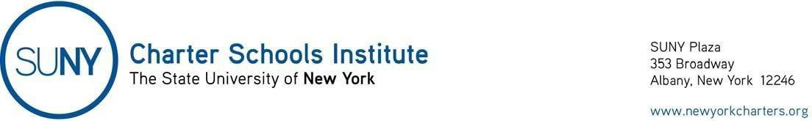

May 10, 2021

Open Meetings Law

Executive Order 202.107 dated May 10, 2021, extends until June 9, 2021, the flexibility to charter school boards of trustees with respect to the Open Meetings Law (so long as certain conditions are met) provided in Governor’s Executive Order 202.79. See the Institute’s original guidance.

