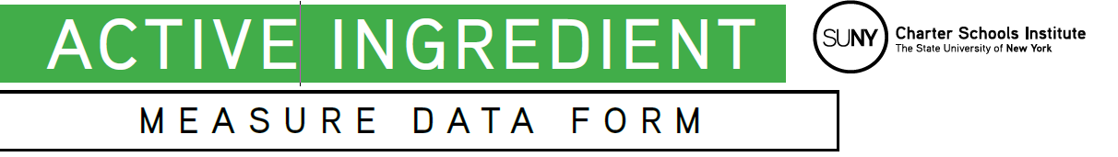
Purpose: After using the Logic Model to develop the “road map” of inputs and outcomes associated with the mission-aligned measure (“MAM”) you intend to capture, this Measure Data Form will support you in defining what you plan to measure, and what tool(s) you will use to ensure the measure is credible, valid, and reliable. If you are have more than one measure/source you’re tracking, you may add more columns or tables as needed to capture information for both measures.
Section 1--School Information
Fill out the basic school information below.
School Name
Grade Levels
Enrollment

Section 2—Mission-Aligned Measure Overview
Fill out the information about the MAM below by referring back to the top light brown boxes of your Logic Model.
School Mission Statement
What is the “special sauce” element of your school for which you want to capture measurable outcomes?
Who are the key team members leading implementation? List names and titles.

Section 3—Measuring Activities and Outputs (Short-Term indicators)
Use the activities and outputs (the light green middle section) from your Logic Model as a starting point to complete the chart below. This will ensure that the outputs you want to measure are clear.
Of the Activities and Outputs listed in your logic model, what are the most critical to assess whether the program elements that contribute to your MAM are being implemented with fidelity? Try to narrow down to no more than 3-5.
What tools do you have at your disposal (or do you need to get/create) to measure these critical outputs? (e.g. surveys, assessments, rubrics, implementation checklists, attendance, etc)
Thinking about the outputs and tools you listed above, what are the most critical indicators you can glean from the tools to assess short-term success (in implementation, services provided, etc)?
Based on the answers above, what are the most critical 3-5 metrics you will look at to assess the activities and outputs?
When/how often will you measure those metrics?
Who is responsible for measuring them?
How will you ensure that staff responsible for data collection implement the tools consistently and accurately?
Who will be responsible for collecting and aggregating data?

Section 4—Measuring Outcomes (Long-term indicators)
Use the outcomes (the red shaded section at far right) from your Logic Model to complete the chart below. This will ensure that the outcomes you want to measure are clear.
Of the Outcomes listed in your logic model, what are the most critical? Try to narrow down to no more than 2-3.
What tools do you have at your disposal (or do you need to get/create) to measure these critical outcomes? (e.g. surveys, assessments, rubrics, etc)
Thinking about the outcomes and tools you listed above, what are the most critical indicators you can glean from the tools to assess success (in student and/or schoolwide outcomes)?
Based on the answers above, what are the most critical 2-3 metrics you will look at to assess the outcomes?
When/how often will you measure those metrics?
Who is responsible for measuring them?
How will you ensure that staff responsible for data collection implement the tools consistently and accurately?
Who will be responsible for collecting and aggregating data?

Section 4—Measurement Tools
Look back at the tools you identified in response to the blue shaded boxes in section 2 and 3 above. Complete the chart below for those tools.
Measurement Instrument
Name and publisher of instrument used to assess/measure outputs and outcomes.
Format
Format of instrument (assessment, survey, rubric, etc)
Author or Creator
Indicate publisher or creator of measurement tool OR indicate if internally developed.
Reference or Sources (if internally developed only)
Describe sources for items and any steps taken to support the credibility of the assessment or instrument.
Plans for Data Collection
How will data be collected? If data collection involves a rubric or other tool that requires scoring, how will scorers be trained to ensure reliability?
Number of Students Assessed
How many students will be measured?
Benchmark/Target (if applicable)
Does your instrument provide (or has your school identified) a benchmark score related to grade level, age, developmental stage, etc, or has the school established a target (could be absolute, growth, or comparison)? If so, what is it and what is the rationale?
Expected Format of Data
In what format will the measure data be? (student level raw score, scale score, aggregate/class average, percent change, etc)

Section 5—How Will You Use This Information?
Use this section to plan how you will use this data to drive program evaluation and improvement.
Anticipated Use
How will you use this information? What will it help you learn?
Program Evaluation
How will you use this information to evaluate and improve your school’s program? Who would be responsible for conducting that evaluation and recommending any potential adjustments?

