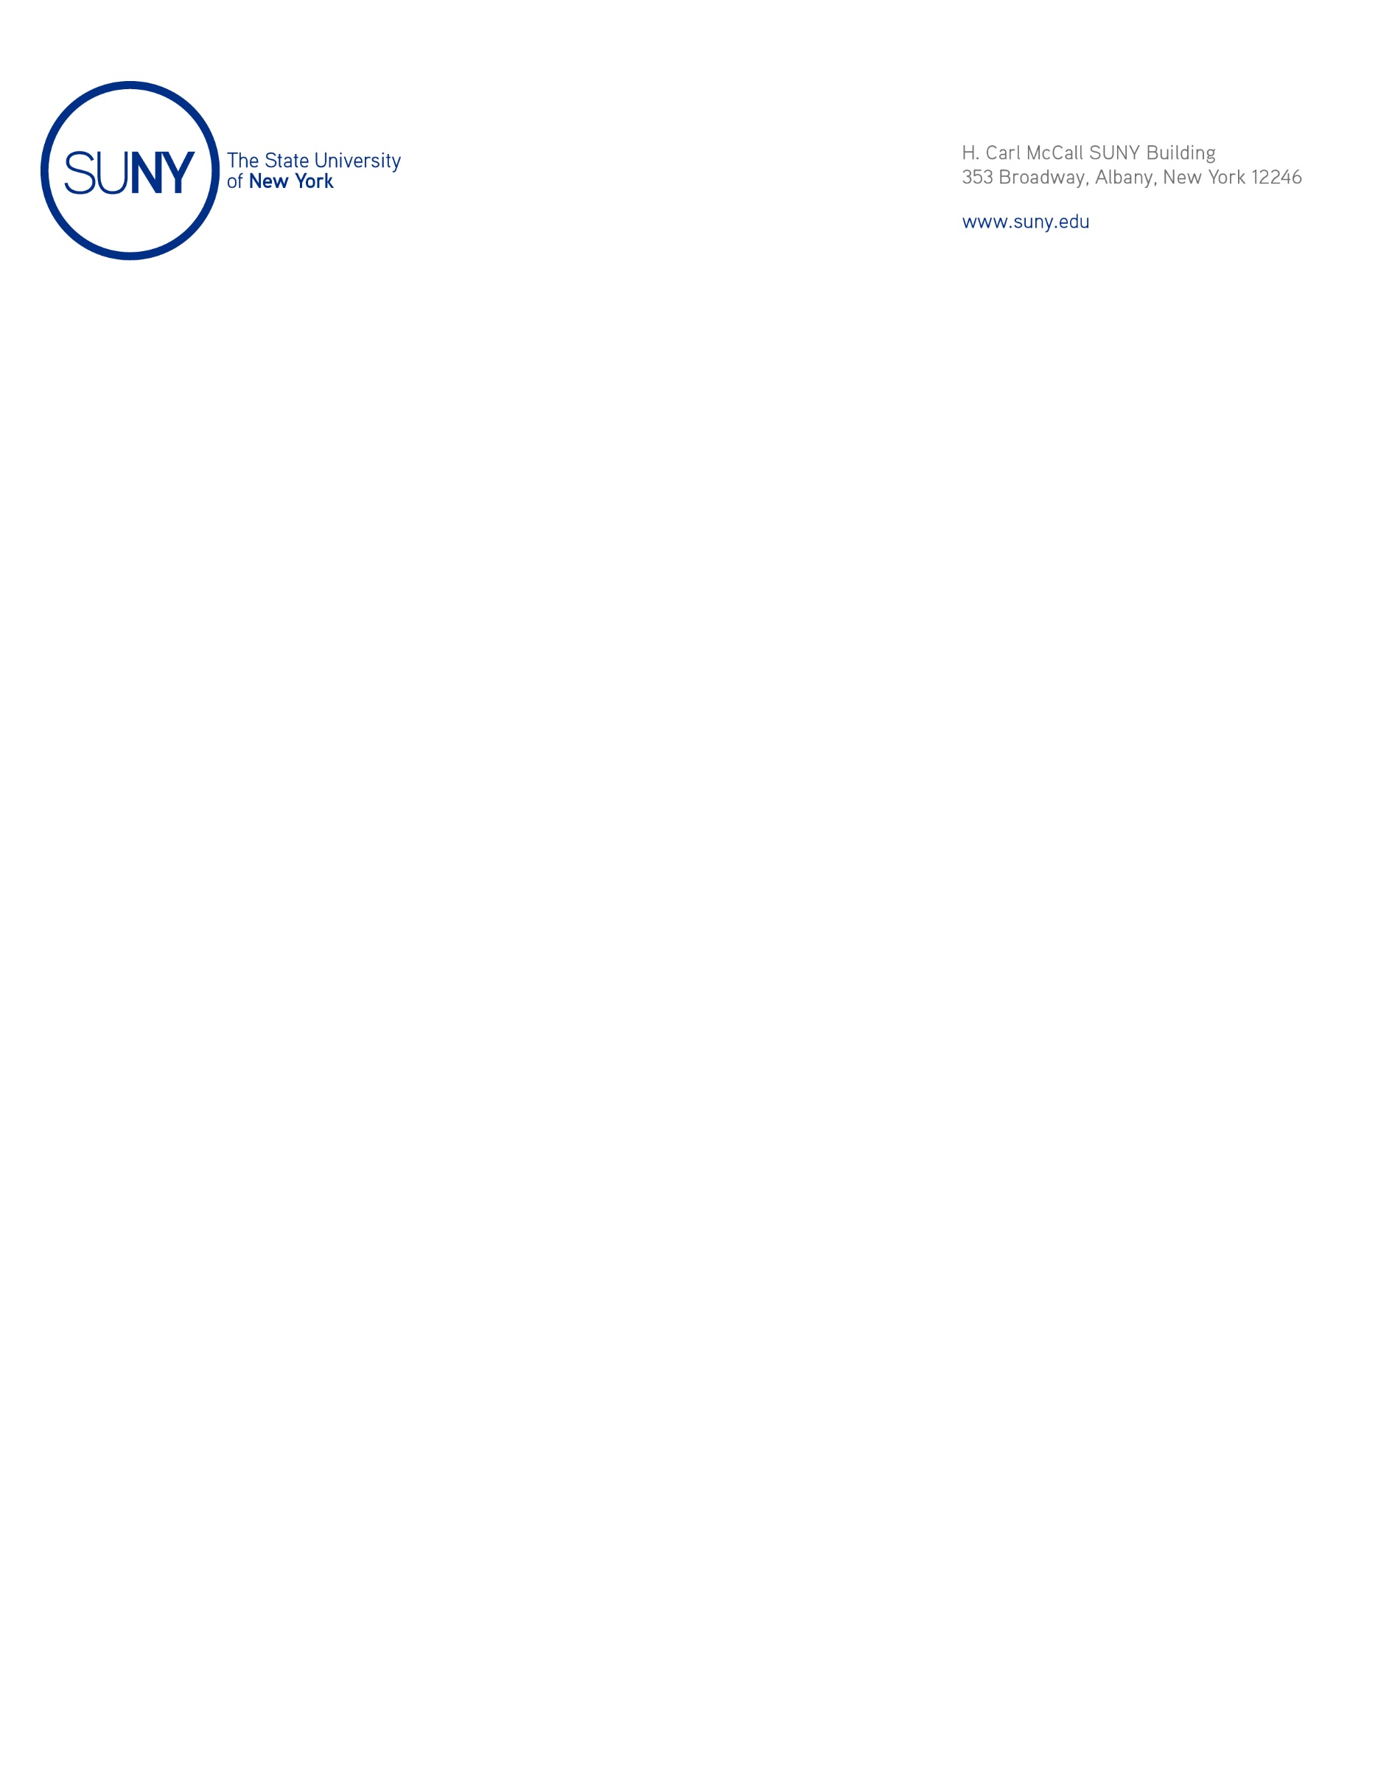

M E M O R A N D U M

October 12, 2023

To: Members of the Charter Schools Committee

From: Joseph W. Belluck, Chair, Charter Schools Committee

Subject: Approval of the Application for Charter Renewal of Uncommon New York City Charter Schools and its Authority to Operate
Brownsville Collegiate Charter School, Excellence Boys Charter School of Bedford Stuyvesant, and Excellence Girls Charter School

Action Requested

The proposed resolution, pursuant to New York Education Law § 2851(4), authorizes the renewal of the authority of Uncommon New York City Charter Schools, a not-for-profit charter school education corporation, to operate Brownsville Collegiate Charter School, Excellence Boys Charter School of Bedford Stuyvesant, and Excellence Girls Charter School each for a term of two years without conditions to align the charter terms with other education corporation charters.

Resolution

I recommend that the Charter Schools Committee adopt the following resolution:

Whereas the Board of Trustees has granted Uncommon New York City Charter Schools (the “Education Corporation”) the authority to operate more than one charter including Brownsville Collegiate Charter School, Excellence Boys Charter School of Bedford Stuyvesant, and Excellence Girls Charter School (individually, the “School” and collectively, the “Schools”); and

Whereas the State University of New York Charter Schools Institute (the “Institute”) asked the Education Corporation to request renewal of its authority to operate the Schools through July 31, 2026, in order to align the expiration dates of the Education Corporation’s charters; and

Whereas the Charter Schools Committee, acting on behalf of the Board of Trustees, as required by Subdivision 2851(4)(e), has considered, prior to approval of the applications for renewal, the means by which the Schools will meet or exceed the enrollment and retention targets of students with disabilities, English language learners, and students who are eligible applicants for the federal Free and Reduced Price Lunch program as set forth in the applications, which targets were prescribed by the Institute on behalf of the Board of Trustees; now, therefore, be it

Resolved that the Education Corporation’s application for authority to operate the Schools be, and hereby is, approved through and including July 31, 2026; and, be it further

Resolved that: 1) each School, as described in the Education Corporation’s application for renewal of authority to operate each School, meets the requirements of the New York Charter Schools Act of 1998 and applicable laws, rules, and regulations; 2) the Education Corporation can demonstrate the ability to operate each School in an educationally and fiscally sound manner; and, 3) approval of the application to renew the authority to operate the Schools, is likely to improve student learning and achievement and materially further the purposes set out in Education Law § 2850(2); and, be it further

Resolved that the Institute, on behalf of the Board of Trustees, be, and hereby is, directed to: 1) enter into a proposed renewal charter or charter revision with the Education Corporation in accordance with this resolution, which shall include such assurances and terms as the Institute shall deem necessary and appropriate; and, 2) thereafter, submit the proposed renewal charter or revision thereof to the New York State Board of Regents for review, comment, and potential approval.

Background

The New York Charter Schools Act of 1998 (as amended) permits the Board of Trustees to renew the charters of education corporations it has authorized and to renew such corporations’ authority to operate charters. Pursuant to Resolution No. 2012-038, dated June 12, 2012, the Board of Trustees delegated authority to renew charters to the Charter Schools Committee.

Pursuant to the Policies for the Renewal of Not-for-Profit Charter School Education Corporations and Charter Schools Authorized by the Board of Trustees of the State University of New York (the “SUNY Renewal Policies”) (last amended September 4, 2013, and available at: https://www.newyorkcharters.org/
wp-content/uploads/SUNY-Renewal-Policies.pdf), the Institute generally conducts a renewal site visit; reviews the information in the renewal application as well as other relevant information such as assessment data and site visit reports; interviews education corporation trustees and staff; and produces a draft renewal report containing its findings and preliminary recommendation. The draft renewal report also contains an evaluation of the performance of an education corporation’s charter over the charter term based on the criteria provided in the renewal benchmarks described in the SUNY Renewal Policies. The education corporation receives a copy of the draft renewal report and is given an opportunity to comment on it before it is finalized. The Institute makes final renewal reports available in its Albany office and at: http://www.suny.edu/about/leadership/board-of-trustees/meetings/meetingNotices.cfm. Copies of applications for charter renewal are on file in the Albany office of the Institute.

As set forth in the Institute’s Renewal Report for Brownsville Collegiate Charter School, Excellence Boys Charter School of Bedford Stuyvesant, and Excellence Girls Charter School, which was distributed to the Board of Trustees, the Institute, pursuant to the SUNY Renewal Policies, conducted a renewal review of the Schools, which are operated by Uncommon New York City Charter Schools. As a result of this review, the Institute recommends that the Education Corporation’s application to extend its authority to operate the Schools be granted for a full term of two years without conditions aligning the charters’ terms. If this resolution is approved, the Education Corporation’s authority to operate the Schools will be renewed through July 31, 2026.

For the charters and education corporation listed above, the Institute properly notified the school district in which the charters are located regarding the receipt of applications for charter renewal and renewal of authority to operate the Schools. As of October 4, 2023, no comments were received.

