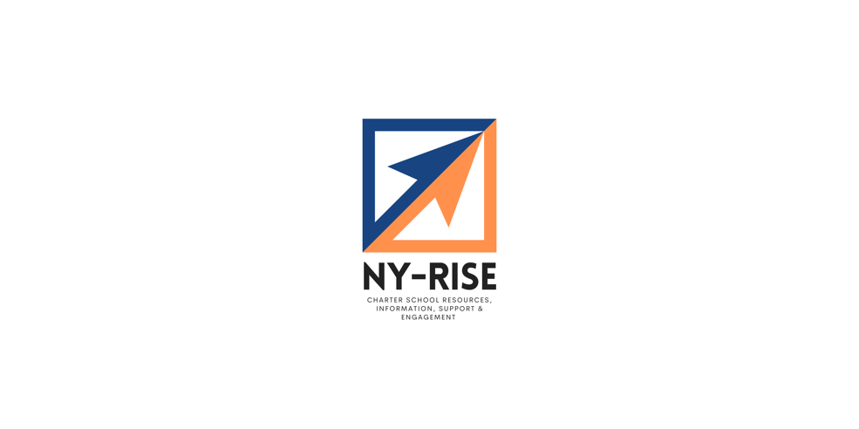
NY-RISE: Upcoming Sessions
January – March 2024

What is NY RISE?

The NY-RISE (Resources, Information, Support, & Engagement) initiative is a three-year professional development series of workshops and webinars to strengthen the individual and collective capacities of charter school stakeholders in four content areas: governance, special education, home-to-school connections, and financial operations. For more information and to access prior webinars, see http://www/nysed.gov/charter-schools/ny-rise. You can also reach out to Robin Chait, Project Director, with questions at rchait@wested.org.
Our Partners
Launched by the New York State Education Department (NYSED), WestEd leads this work alongside our partner organizations: the Center for Learner Equity, Manhattan Strategy Group, and Tugboat Education.
Upcoming Sessions

Thinking Past the Day-to-Day, Strategic Planning for Long Term Success
- Date: Thursday, January 18, 2024
- Time: 12:00 pm- 1:30 pm
- Audience: Governing board members
- Register here - https://bit.ly/3vIezk8
Description: Governance is one of the most impactful factors in the success of a charter school. Strong boards can contribute enormously to a school's academic, financial, and operational effectiveness; ineffective boards can simply drag their schools down.
This virtual training session will focus on the vital role charter school boards play in setting goals and objectives and engaging in longer term strategic planning. It will outline a process for setting strategic goals and objectives and monitoring progress. We will also wrestle with the challenges boards face and identify ways board preparedness and strong strategic planning can ultimately lead to a high-performing, efficiently operated charter school.
Join Paul O’Neill, President of Tugboat Education and Tara Bergfeld, Senior Education Finance Associate at WestEd.

Elevating Family Engagement with the Academic Parent Teacher Teams Model
  - Date: Monday, January 29, 2024
  - Time: 2:00 pm- 3:00 pm
  - Audience: School leaders, family engagement coordinators, teachers
  - Register here - http://bit.ly/3NWkR6k
Description: Are you passionate about transforming the family experience within educational settings? Look no further—our upcoming webinar is tailored just for you! Geared towards teachers and education leaders, this session is designed to build your capacity to implement effective family engagement strategies based on the Academic Parent-Teacher Teams (APTT) model. Academic Parent-Teacher Teams (APTT) is a model of family engagement that is grounded in the notion that schools can thrive when families and teachers work together, as genuine partners, to maximize student learning inside and outside of school.
This session will take a deep dive into the APTT framework, explaining the elements and principles behind them, so you can implement some of these strategies in your school building. Join Faith Burtamekh for this exciting session--she brings extensive expertise in teaching, training, coaching, and driving systemic change, and promises to leave you hooked on elevating your family engagement efforts!
Budgeting During Lean Times
- Date: Thursday, February 8, 2024
- Time: 2:00 pm- 3:00 pm
- Audience: School leaders, finance staff
- Register here - https://bit.ly/3vFjeDs
Description: Enrollment declines, inflation, and teacher shortages have had varying impacts on charter school budgets over the past several years. As charter school leaders adjust their budgets to account for leaner times, it is helpful to work through processes that help school teams reassess their priorities and ensure that programming and resources are aligned with student needs. This session with Matt Major, Tara Bergfeld, and the NY-RISE team will walk school leaders through a process to understand available resources, evaluate their data to inform financial decision-making, and familiarize participants with strategic budget practices.
Ensuring Excellence: Navigating Distress to Sustain High-Quality Schools
- Date: Thursday, February 29, 2024
- Time: 2:30 pm- 4:00 pm
- Audience: School leaders, board members
- Register here
Description: Looking for ways to ensure high-quality and sustainable schools? This session not only involves valuable insights from authorizers, school leaders, and board members across the nation (through a seminal research series conducted by the National Charter School Resource Center), but it also delves into a follow-up study conducted with New York charter schools. This session will walk leaders and governing board members through the distinct characteristics of school distress before it negatively impacts student outcomes. Join Aimee Evan, Senior Research Associate, WestEd and Janet R. Kline, Ph.D., Associate, Education Research, NYSED for this valuable session.

Making the Grade: Post-Secondary Pathway Planning for the Future
- Date: Wednesday, March 5, 2024
- Time: 8:00 am- 9:30 am
- Audience: High school guidance and college counselors, special education team leaders
- Register here - https://bit.ly/48SGFri
Description: This session will provide guidance about how to support students with IEPs in preparing for the future. It will define roles and responsibilities for managing and planning for students’ graduation students’ graduation following NYS diploma requirements. It will also help participants examine IEP transition plans and exit summaries to support economic self-determination. Join Meghan Fitzgerald with the Center for Learner Equity and Uncommon Schools for this valuable session designed for high school guidance and college counselors and special education team leads.
Financial Management for Successful Grants Implementation
- Date: Wednesday, March 13, 2024
- Time: 3:00 pm- 4:30 pm
- Audience: Finance staff
- Register here - https://bit.ly/3HkntqR
Description: Misinterpreting complex grant provisions and federal fiscal requirements can result in audit and fiscal monitoring findings with significant implications for federal education program implementation. Financial leaders in charter schools should have a basic understanding of how existing federal regulations apply when it comes to federal education grants, as well as the resources available to assist with decision-making regarding federal fiscal requirements.
This session will delve into the fundamentals of federal regulations, specifically focusing on the principles of financial management, internal controls, and the timely obligation of funds. Participants will explore the different components of the federal regulations governing the administration of federal education grants as defined by the Education Department General Administrative Regulations (EDGAR), the Uniform Grant Guidance, and the General Education Provisions Act (GEPA).

