
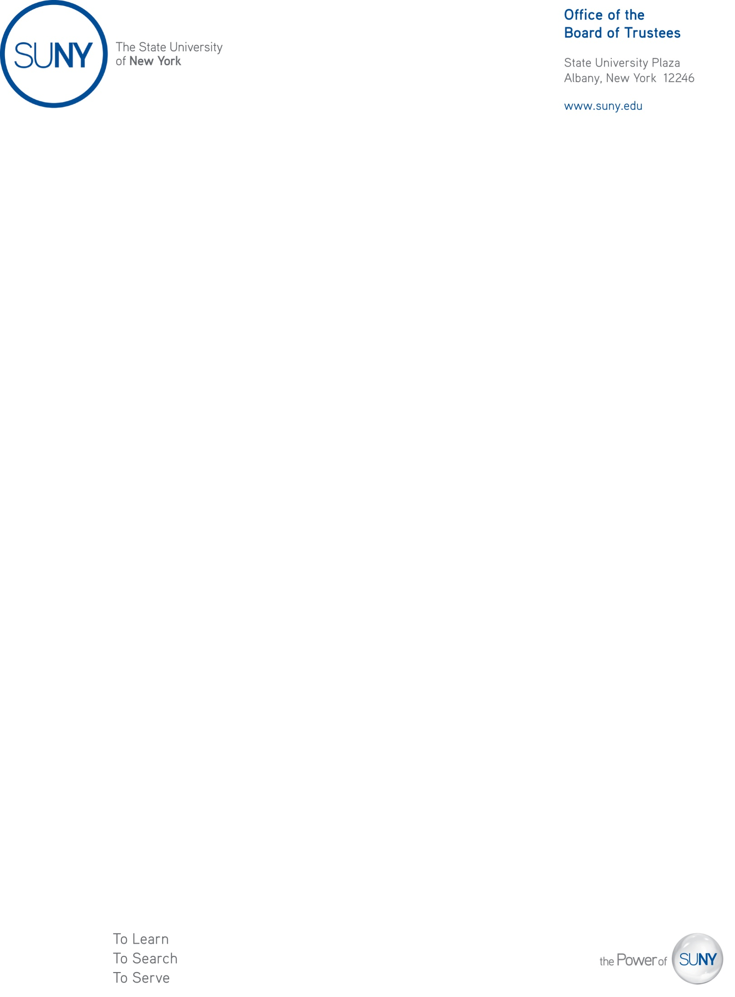

M E M O R A N D U M

October 15, 2025

To: Members of the Charter Schools Committee

From: Joseph W. Belluck, Chair, Charter Schools Committee

Subject: Approval of Revision to Success Academy Charter School – Bronx 5 Lower to Operate as Strive Charter School

Action Requested

The proposed resolution authorizes a charter revision, pursuant to New York Education Law § 2852(7), for Success Academy Charter Schools - NYC, an existing education corporation authorized by the Board of Trustees to operate more than one charter school, to establish a separate education corporation with the authority to operate the charter for Success Academy Charter School – Bronx 5 Lower under the education corporation and charter name “Strive Charter School.”

Resolution

I recommend that the Charter Schools Committee adopt the following resolution:

Whereas the Board of Trustees authorizes Success Academy Charter Schools - NYC (“SACS NYC” or the Education Corporation”), an education corporation with the authority to operate more than one charter school, including Success Academy Charter School – Bronx 5 Lower (“Success Bronx 5 Lower” or the “School”) which is chartered to serve 640 students in grades K-4 for the 2026-27 school year the last year of the current charter term; and

Whereas, SACS NYC has requested to revise its charter to transfer authority to operate Success Academy Charter School – Bronx 5 Lower to a separate to be formed education corporation, Strive Charter School (“Strive”), under a separate board of trustees, to offer an innovative model using SACS NYC’s educational program (the “Proposed Change in Program”); and

Resolved that the Proposed Change in Program be, and hereby is approved; and, be it further

Resolved that the Charter Schools Committee finds: 1) the Proposed Change in Program meets the requirements of the New York Charter Schools Act of 1998 (the “Act”) and all applicable laws, rules, and regulations; 2) approval of the Proposed Change in Program (together with the other terms of the proposed charter) would permit Strive to operate in an educationally and fiscally sound manner; and, 3) approval of the Proposed Change in Program is likely to improve student learning and achievement and materially further the purposes set out in Education Law § 2850(2); and, be it further

Resolved that approving the Proposed Change in Program would have a significant educational benefit to the students expected to attend the charter school within the meaning of Subdivision 2852(2)(d); and, be it further

Resolved that the Institute be, and hereby is, directed to: 1) enter into a proposed revision to SACS NYC’s charter and a proposed charter with Strive in accordance with this resolution; each of which shall include such assurances and terms as the Institute shall deem necessary and appropriate; and, 2) thereafter submit such proposed revision and charter to the New York State Board of Regents for its review, comment, and potential approval.

Background

Pursuant to Resolution No. 2012-038, dated June 12, 2012, the Board of Trustees delegated to the Charter Schools Committee the authority to approve or deny applications to establish new charter school education corporations, and applications by existing education corporations for authority to operate additional schools as well as revise charters including the approval to transfer the authority to operate a charter.

The New York Charter Schools Act of 1998 (the “Act”) education corporations to operate more than one charter. Upon approval of its authorizer, an education corporation may transfer its authority to operate one of its charters to another education corporation or to be formed education corporation.

The Board of Trustees granted Success Academy Charter Schools – NYC (the “Education Corporation”) the authority to operate Success Academy Charter School – Bronx 5 Lower (the “School”) on October 8, 2014, and the School is currently in its fourth year of offering instruction.

The overall health of the Education Corporation – academically, fiscally, and operationally – is positive. The Institute made its Summary of Findings for the proposal available to the Board of Trustees (copy on file in the Office of the Secretary and the Albany office of the Institute).

The Institute reviewed the proposed program elements (including enrollment projections, curriculum, and staffing) and budgets and found them satisfactory. The Institute also reviewed the proposed revision from the legal and fiscal perspectives and finds it suitable under the Act and applicable law. Based on the foregoing, the Institute recommends the Charter Schools Committee approve the requested revision.

For the proposal listed above, the Institute, pursuant to Education Law
§ 2857(1), notified the school district in which the school is located regarding the receipt of the application for revision. As of October 6, 2025, the Board of Trustees received no district comments.

