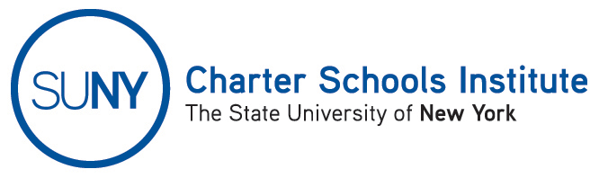

FOR INFORMATION ONLY: NO ACTION REQUIRED

PUBLIC NOTICE

TO: General Public
FROM: SUNY Charter Schools Institute (on behalf of the State University of New York Board of Trustees)
SUBJECT: First Notice of Charter Revision(s) - Receipt
DATE: September 15, 2015
This Notice is to inform you that the State University of New York Board of Trustees (the “SUNY Trustees”), in its capacity as a charter authorizer, has received application(s) to revise the charter(s) of the charter school(s) listed below. Further, the SUNY Trustees, or their designees, the SUNY Charter Schools Committee or SUNY Charter Schools Institute (the “Institute”), anticipate consideration of this request as soon October 15, 2015.

A description of the proposed actions follows:

- Bronx Charter School for Excellence, located at 1960 Benedict Avenue, Bronx, NY 10462 and 1804 Holland Avenue, Bronx, NY 10462, in Community School District 11, currently serving approximately 700 students in grades K-8, has requested to enter into a management agreement with The Friends of the Bronx Charter School for Excellence, which may be renamed or file to do business as “Excellence Schools, Inc.,” a New York not-for-profit, charter-management organization, to manage its educational programs and administrative functions.

If you would like to comment on the proposed revision(s), please send any comments to charters@suny.edu or the address below.

For further information on this notice, please contact Institute Executive Deputy Director and General Counsel Ralph Rossi at the address or phone number below or ralph.rossi@suny.edu.

