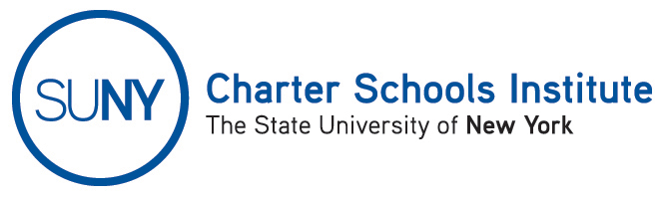

FOR INFORMATION ONLY: NO ACTION REQUIRED
PUBLIC NOTICE PURSUANT TO EDUCATION LAW § 2857(1)
TO: General Public
FROM: SUNY Charter Schools Institute (on behalf of the State University of New York Board of Trustees)
SUBJECT: First Notice of Receipt of Charter Revision(s)
DATE: January 22, 2016
This first Notice is to inform you that the State University of New York Board of Trustees (the “SUNY Trustees”), in its capacity as a charter authorizer, received (an) application(s) to revise the charter(s) of the charter school(s) listed below. Further, the SUNY Trustees anticipate consideration of this request as soon February 22, 2016.

- Central Queens Academy Charter School, located at 55-30 Junction Blvd., Elmhurst, NY 11694 and 88-24 Myrtle Ave., Glendale, NY 11385, in Community School District 24, currently serving approximately 380 students in grades 5-8, requests to add a high school program beginning in the 2016-17 school year with approximately 100 students in the 9th grade and growing by one grade each year, and requests to add an elementary program beginning in the 2016-17 school year with approximately 100 students in Kindergarten and growing by one grade each year. At full capacity the school would serve approximately 1305 students in grades K-12. The 2016-17 school year is the final year of the school’s current charter term. If SUNY agrees to accept such grade expansions, SUNY would also amend the school’s charter such that the expansion will be contingent upon the school: 1) providing a renewal application with the grade expansion; 2) qualifying for at least a short-term renewal pursuant to the SUNY Renewal Policies; and, 3) being in good standing at such time. SUNY acknowledges that, if approved, the school may not implement both revisions. Alternatively, SUNY may not approve the addition of both programs. In such cases, the revision(s) would be one to the renewal process only as described above.

The Institute would welcome any comments you might wish to provide. Please direct any comments to the address below or to charters@suny.edu. For further information on this notice, please contact Institute Executive Deputy Director and General Counsel Ralph Rossi at the telephone number below or ralph.rossi@suny.edu.

