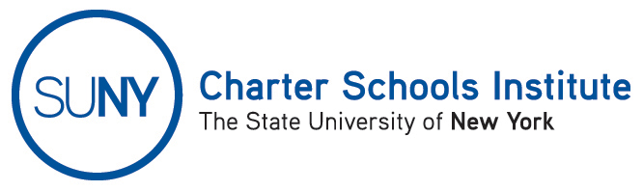

FOR INFORMATION ONLY: NO ACTION REQUIRED

PUBLIC NOTICE

TO: General Public
FROM: SUNY Charter Schools Institute (on behalf of the Board of Trustees of the State University of New York)
SUBJECT: Notice of Receipt and Pending Action on Charter Revision Applications
DATE: September 12, 2014

This Notice is to inform you that the State University of New York Board of Trustees (the “SUNY Trustees”), in its capacity as a charter authorizer, has received application(s) to revise the charter(s) of the charter school(s) listed below. Further, the SUNY Trustees, or their designee, the SUNY Charter Schools Institute (the “institute”), anticipates consideration of this request as soon October 8, 2014.

Description(s) of the proposed action(s) follow:

- New World Preparatory Charter School, located at 26 Sharpe Avenue, Staten Island, NY 10302, in Community School District 31, currently serving approximately 300 students in grades 6-8, proposes changes to its relationship and management agreement with Victory Schools Inc. to move from a full service model to a service menu model while changing its staffing structure to allow for staff development and instructional support directly from school personnel.

The Institute would welcome any comments you might wish to provide. Please direct any comments to the address below or to charters@suny.edu.
For further information on this Notice, please contact Institute Executive Deputy Director and General Counsel Ralph Rossi at the telephone number below or ralph.rossi@suny.edu.

