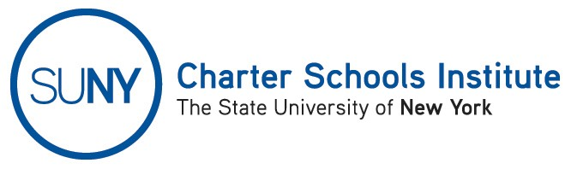

FOR INFORMATION ONLY: NO ACTION REQUIRED

UPDATED NOTICE PURSUANT TO EDUCATION LAW SUBDIVISION 2857(1)

TO: Public and Nonpublic Schools: Same Geographic Area as Proposed Charter Schools

FROM: SUNY Charter Schools Institute (on behalf of the State University of New York Board of Trustees)
SUBJECT: UPDATED NOTICE OF APPROVAL OF CHARTER SCHOOL APPLICATIONS
DATE: November 4, 2014
PLEASE TAKE NOTICE that pursuant to New York Education Law § 2857(1), the State University of New York Board of Trustees (the “SUNY Trustees”), in its capacity as a charter authorizer, approved the following charter applications at its Charter Schools Committee meeting on June 4, 2014:

Proposed Community School District of Location | Proposed Charter School Name | Planned Grades Year One | Planned Grades Year Five | # of Students Planned in Year One | # of Students Planned in Year Five | Desired Opening Date | Proposed Charter Management Organization
New York City Community School District (“NYC CSD”) 6 or 28 | Amber Charter School II | K-1 | K-5 | 250 | 650 | September 2015 | None
NYC CSD 10 | Atmosphere Academy Public Charter School | 6 | 6-10 | 120 | 576 | August 2015 | None
NYC CSD 11 | Bronx Charter School for Better Learning II | K | K-4 | 75 | 375 | August 2015 | None
NYC CSD 13 | Brooklyn Prospect Charter School Downtown | K, 1, 2, 6 | K-8 | 225 | 475 | September 2015 | None
NYC CSD 7 or 8 | Storefront Academy Charter School | K-1 | K-5 | 100 | 288 | August 2015 | None
Elmira City School District | Finn Academy: An Elmira Charter School | K-3 | K-7 | 180 | 396 | August 2015 | None
NYC CSD 13 | The International Charter School of New York | K-1 | K-5 | 155 | 547 | August 2015 | None

Please take further notice that the SUNY Trustees forwarded the approved applications to the New York State Board of Regents for final approval, and all applications except Amber Charter School II and Storefront Academy Charter Schools were approved by operation of law consistent with the New York Charter Schools Act of 1998 (as amended). SUNY will provide no further notice on the finally approved applications.

For additional information regarding this Notice, please contact the Institute’s Executive Deputy Director and General Counsel, Ralph A. Rossi II, at (518) 433-8277 or ralph.rossi@suny.edu.

41 State Street, Suite 700, Albany, New York 12207  Phone: (518) 433-8277  Fax: (518) 427-6510 www.newyorkcharters.org

