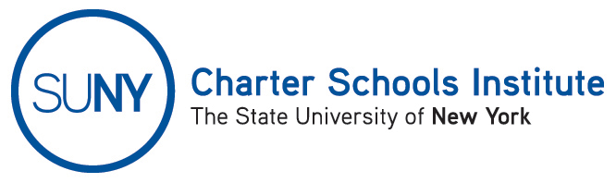

FOR INFORMATION ONLY: NO ACTION REQUIRED

PUBLIC NOTICE

TO: General Public
FROM: SUNY Charter Schools Institute (on behalf of the State University of New York Board of Trustees)
SUBJECT: Notice of Receipt and Pending Action on Charter Revision Application
DATE: September 18, 2014

This Notice is to inform you that the State University of New York Board of Trustees (the “SUNY Trustees”), in its capacity as a charter authorizer, has received application(s) to revise the charter(s) of the charter school(s) listed below. Further, the SUNY Trustees, or their designee, the SUNY Charter Schools Institute (the “Institute”), anticipates consideration of this request as soon November 5, 2014.

Description(s) of the proposed action(s) follow:

- King Center Charter School, located at 104 Lang Avenue, Buffalo, NY 14215, in the Buffalo City School District, currently serving approximately 360 students in grades K-8, has requested to amend the not-for-profit charter school education corporation’s current by-laws to, among other things, include a mechanism to address potential conflicts of interest on the education corporation’s board of trustees.

The Institute would welcome any comments you might wish to provide. Please direct any comments to the address below or to charters@suny.edu.
For further information on this Notice, please contact Institute Executive Deputy Director and General Counsel Ralph Rossi at the telephone number below or ralph.rossi@suny.edu.

