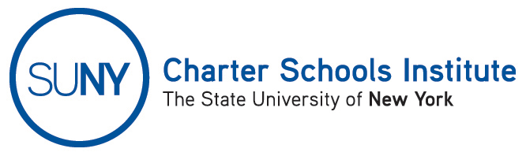

FOR INFORMATION ONLY: NO ACTION REQUIRED

PUBLIC NOTICE

TO: General Public
FROM: SUNY Charter Schools Institute (on behalf of the State University of New York Board of Trustees)
SUBJECT: Notice of Receipt and Pending Action on Charter Extension Application
DATE: January 14, 2015

This Notice is to inform you that the State University of New York Board of Trustees (the “SUNY Trustees”) has received an application to extend the charter of the charter school listed below. Further, the SUNY Trustees, or their SUNY Charter Schools Institute (the “Institute”), anticipate consideration of the application on or about March 11, 2015. Any changes to scheduled actions, which track with the meetings of the Charter Schools Committee, will be posted online here: http://www.suny.edu/about/leadership/board-of-trustees/meetings/meetingNotices.cfm.

Invictus Preparatory Charter School, located at 370 Fountain Avenue, Brooklyn NY 11208 in Community School District 19, seeks an extension of its charter from December 13, 2015 to July 31, 2016. According to the extension application, the school would serve approximately 342 students in grades 5-8 during the 2015-16 school year.

The Institute would welcome any comments you might wish to provide. Please direct any comments to the address, fax or email below.

For further information on this notice, please contact Institute Executive Deputy Director and General Counsel Ralph Rossi at the number below or ralph.rossi@suny.edu.

