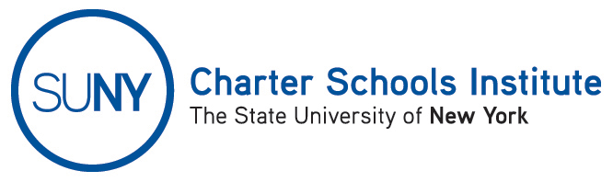

FOR INFORMATION ONLY: NO ACTION REQUIRED

PUBLIC NOTICE

TO: General Public
FROM: SUNY Charter Schools Institute (on behalf of the Board of Trustees of the State University of New York)
SUBJECT: Notice of Receipt and Pending Action on Charter Revision Applications
DATE: September 5 2014

This Notice is to inform you that the State University of New York Board of Trustees (the “SUNY Trustees”), in its capacity as a charter authorizer has received applications to revise the charter(s) of the charter school(s) listed below. Further, the SUNY Trustees, or their designee, the SUNY Charter Schools Institute (the “Institute”), anticipates consideration of this request as soon October 6, 2014.

Description(s) of the proposed action(s) follow:

- Achievement First Apollo Charter School, located at 350 Linwood Street, Brooklyn, NY 11208, in Community School District 19, currently serving approximately 514 students in grade K-5, has requested to change the school’s current admissions policy to provide a weighted lottery incorporating at-risk design factors for applicants who qualify for free or reduced price lunch (“FRPL”), are English Language Learners (“ELLs”), or are eligible for special education services.

The Institute would welcome any comments you might wish to provide. Please direct any comments to the address below or to charters@suny.edu.
For further information on this notice, please contact Institute Executive Deputy Director and General Counsel Ralph Rossi at the telephone number below or ralph.rossi@suny.edu.

