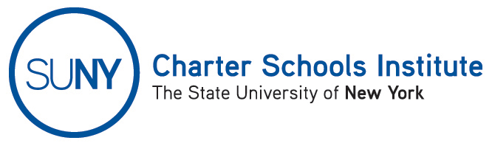

FOR INFORMATION ONLY: NO ACTION REQUIRED

PUBLIC NOTICE

TO: General Public
FROM: SUNY Charter Schools Institute (on behalf of the Board of Trustees of the State University of New York)
SUBJECT: Notice of Receipt and Pending Action on a Charter Renewal Application
DATE: September 5, 2014

This notice, pursuant to Education Law § 2857(1), is to inform you that the State University of New York Board of Trustees (the “SUNY Trustees”) has received applications to extend and/or renew the charter(s) of the charter schools listed below. Further, the SUNY Trustees, or their Charter Schools Committee, anticipate consideration of the renewal applications in January or February of 2015. Extensions may be considered by the SUNY Charter Schools Institute (the "Institute") as soon as October 6, 2014. Any changes to scheduled actions will be posted online here: http://www.newyorkcharters.org/public-notices/.

Child Development Center of the Hamptons Charter School, located at 110 Stephen Hands Path, Wainscott, NY 11975, seeks a five year renewal of its charter commencing on August 15, 2015. According to the renewal application, the school would serve approximately 76 students in grades K-5.

The Institute would welcome any comments you might wish to provide. Please direct any comments to the address or email below.

For further information on this notice, please contact Institute Executive Deputy Director and General Counsel Ralph Rossi at: (518) 433-8277 or ralph.rossi@suny.edu.

