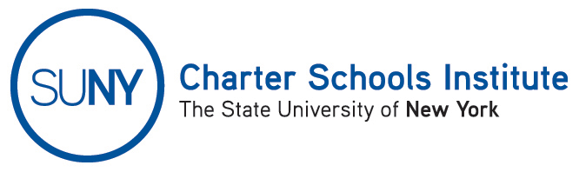

FOR INFORMATION ONLY: NO ACTION REQUIRED

PUBLIC NOTICE

TO: General Public
FROM: SUNY Charter Schools Institute (on behalf of the State University of New York Board of Trustees)
SUBJECT: Notice of Receipt of Charter Revision Applications
DATE: January 6, 2015
This Notice is to inform you that the State University of New York Board of Trustees (the “SUNY Trustees”), in its capacity as a charter authorizer has received applications to revise the charter(s) of the charter school(s) listed below. Further, the SUNY Trustees, or their designee, the SUNY Charter Schools Institute (the “Institute”), anticipates consideration of this request as soon February 3, 2015.

A description of the proposed actions follows:

True North Troy Preparatory Charter School, located at 2 Polk Street, Troy, NY 12180, in the Troy City School District, currently serving approximately 455 students in grades K-3, 5-8, has requested to change the school’s current admissions policy which defines “at-risk” students as being eligible for free or reduced price lunch, a resident of a school district in which all schools in the district serving grade eight are designated as "in need of improvement" under the No Child Left Behind Act (“NCLB”); or currently attending an elementary school either designated as "in need of improvement" under the NCLB or with an average fourth grade math and ELA proficiency rate below the state average. The school requests that the definition of “at-risk” student be changed to a student who resides within a school district listed as a High Needs/Resource district according to the most recent State school report card.

Please take further Notice that the SUNY Trustees will send the proposed revisions to the Board of Regents for approval or action consistent with the New York Charter Schools Act of 1998.

For further information on this notice, please contact Institute Executive Deputy Director and General Counsel Ralph Rossi at the phone number above or ralph.rossi@suny.edu.

