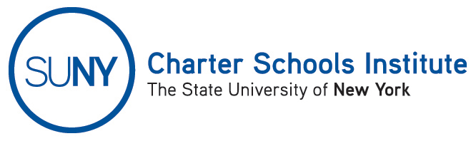

FOR INFORMATION ONLY: NO ACTION REQUIRED

PUBLIC NOTICE

TO: General Public
FROM: SUNY Charter Schools Institute (on behalf of the State University of New York Board of Trustees)
SUBJECT: Second Notice of Charter Revision(s) – SUNY Trustee Approval
DATE: January 29, 2016

This updated Notice is to inform you that the State University of New York Board of Trustees (the “SUNY Trustees”), in its capacity as a charter authorizer, approved the revision(s) of the charter(s) of the charter school(s) listed below.

A description of the proposed actions follows:

- New Roots Charter School, located at 116 N. Cayuga Street, Ithaca, NY 14851 in the Ithaca City School District, currently serving approximately 135 students in grades 9-12, requests to decrease its projected enrollment for the remainder of the 2015-16 school year and for the 2016-17 school year, the last year of the current charter term, from 200 students to 160 students.

Please take further Notice that the SUNY Trustees will send the proposed revision(s) to the New York State Board of Regents for approval or action consistent with the New York Charter Schools Act of 1998.

For further information on this notice, please contact Institute Executive Deputy Director and General Counsel Ralph Rossi at the phone number above or ralph.rossi@suny.edu.

